**Indira Gandhi Delhi Technical University for Women**

**(Established by Govt. of Delhi vide Act 09 of 2012)**

**(Formerly Indira Gandhi Institute of Technology)**

**Kashmere Gate, Delhi - 110006**



**LABORATORY FILE**

**for**

**OOP using C++**

**MCA-104**

**Submitted To: Submitted by:**

Ms. Ankita Roopal Mittal

IT Department MCA 2nd Sem

IGDTUW, Delhi 02004092019

**Ques 1**: Write a program to print “Hello World”.

**Solution 1**:

#include<iostream>

using namespace std;

int main ()

{

cout<<"Hello World";

return 0;

}

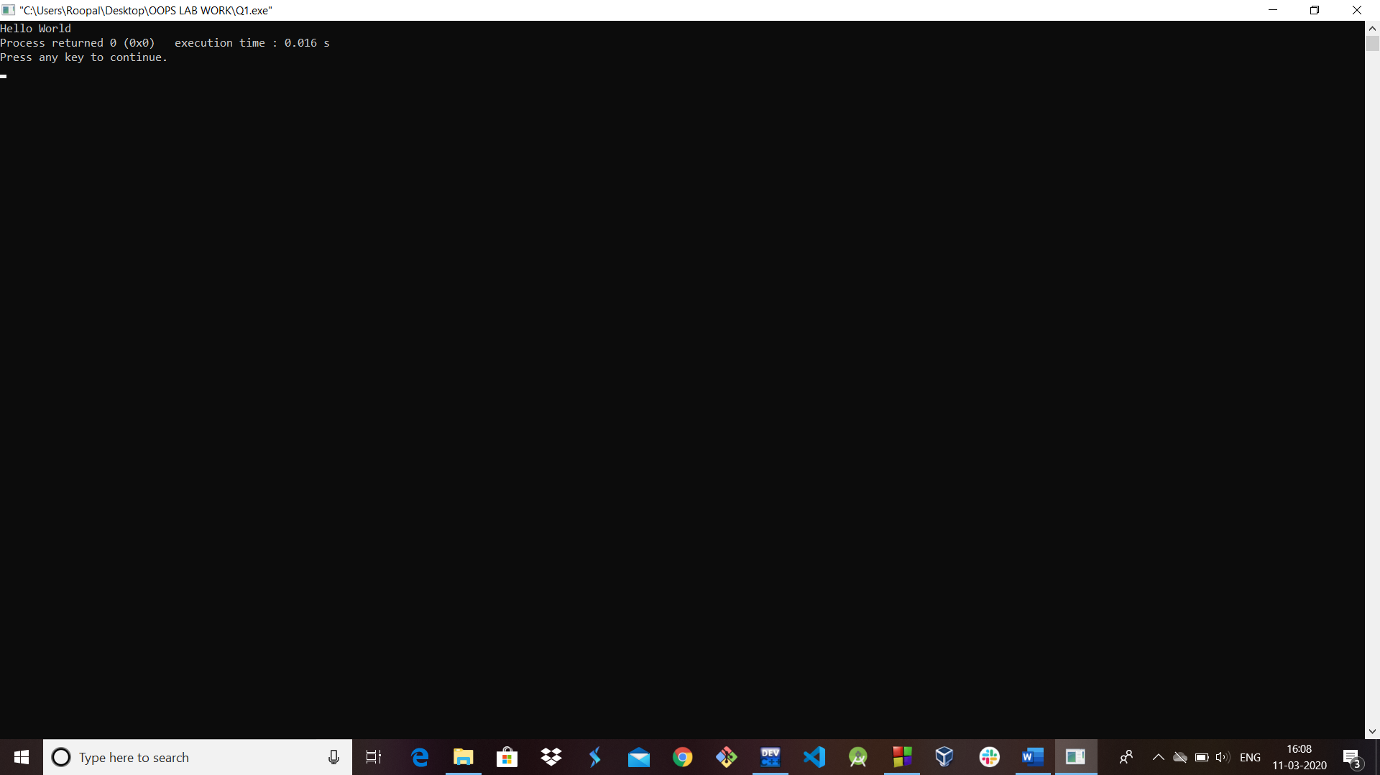

**Ques 2:** Write a program to print factorial of a number entered by the user.

**Solution 2:**

#include<iostream>

using namespace std;

//Function returning factorial of a given number

int fact (int n)

{

//base case

if(n==0)

return 1;

//induction hypothesis

int ans=fact(n-1);

//induction step

int myAns=n*ans;

return myAns;

}

int main ()

{

int n, f;

cout<<"Enter a number: ";

cin>>n;

f=fact(n);//Function call

cout<<"Factorial of "<<n<<" is "<<f;

return 0;

}

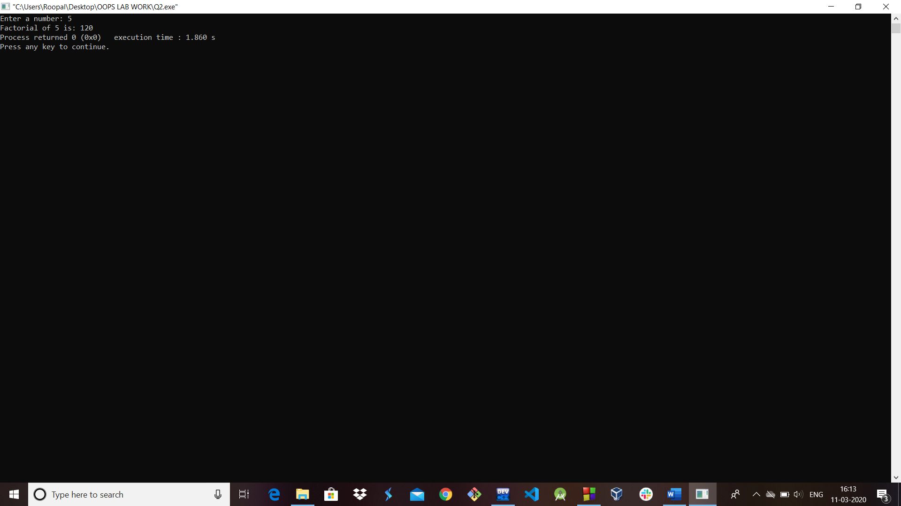

**Ques 3:** Write a program to print Fibonacci series up to n.

**Solution 3:**

#include<iostream>

using namespace std;

int main ()

{

int n, c;

//Initialise first two numbers a and b

int a=0, b=1;

cout<<"Enter the number of terms: ";

cin>>n;

cout<<n<<" numbers of fibonacci series are: ";

cout<<a<<" "<<b;

for (int i=2; i<n; i++)

{

c=a+b;

cout<<" "<<c;

a=b;

b=c;

}

return 0;

}

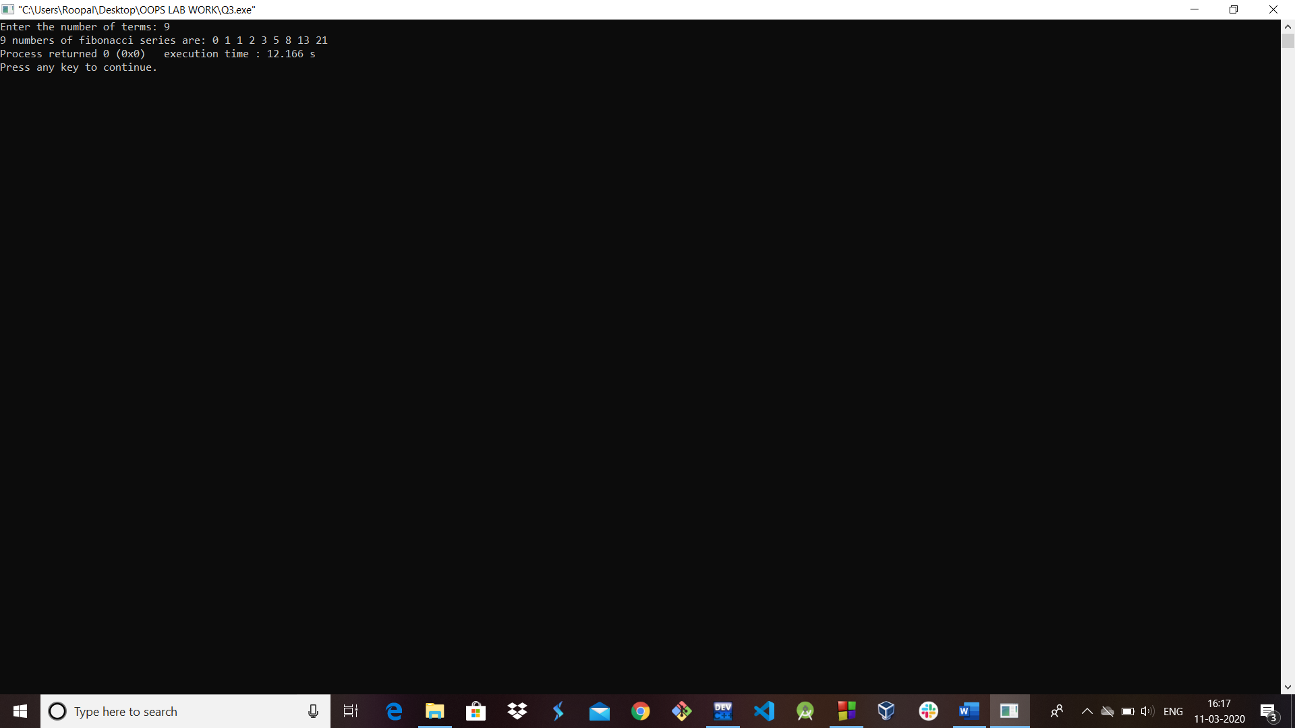

**Ques 4:** Write a program to read an employee’s information from the user and print the same. Employee’s information shall include employee ID (*int*), employee name (*string*) and employee salary (*float*).

**Solution 4:**

#include<iostream>

using namespace std;

class employee {

private:

int emp_Id;

char emp_name[30];

float emp_salary;

public:

void getData ()

{

cout<<"Enter information of employee\n";

cout<<"Enter Employee's ID: ";

cin>>emp_Id;

cout<<"Enter Employee's Name: ";

cin>>emp_name;

cout<<"Enter Employee's Salary: ";

cin>>emp_salary;

}

void putData ()

{

cout<<"\n Display information of employee";

cout<<"\n Employee's ID: "<<emp_Id;

cout<<"\n Employee's Name: "<<emp_name;

cout<<"\n Employee's Salary: "<<emp_salary;

}

};

int main ()

{

employee emp; //creating object emp of class employee

emp.getData(); //function call

emp.putData(); //function call

return 0;

}

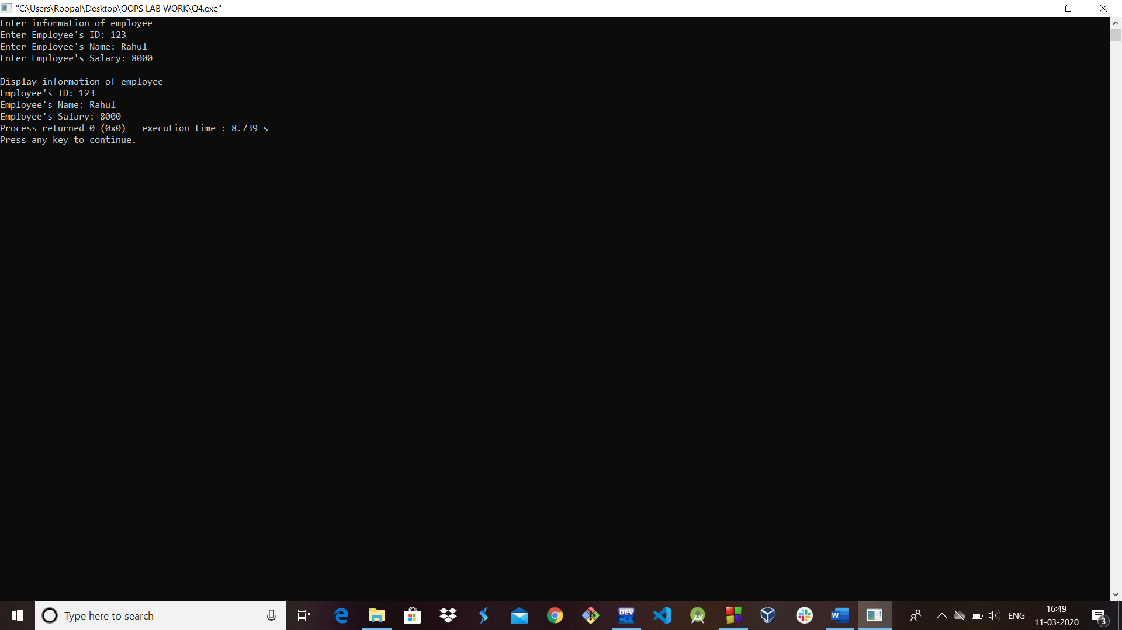

**Ques 5:** Write a program to take two integer inputs and output their sum, difference, product and division (quotient and remainder) as result based on a third input. (operator).

**Solution 5:**

//input integers and output according to the operator

#include<iostream>

using namespace std;

int main ()

{

int a, b;

char op;

cout<<"\n Enter any two numbers:: ";

cin>>a>>b;

cout<<"Enter any operator of your choice:: ";

cin>>op;

switch(op){

case '+': cout<<"Sum is "<<(a+b) <<endl;

break;

case '-': cout<<"Difference is "<<(a-b) <<endl;

break;

case '/': cout<<"Quotient:: "<<(a/b);

cout<<" Remainder:: "<<(a%b) <<endl;

break;

case '*': cout<<"Product is "<<(a*b) <<endl;

break;

default: cout<<"\n Wrong input!!";

break;

}

return 0;

}

**Output:**

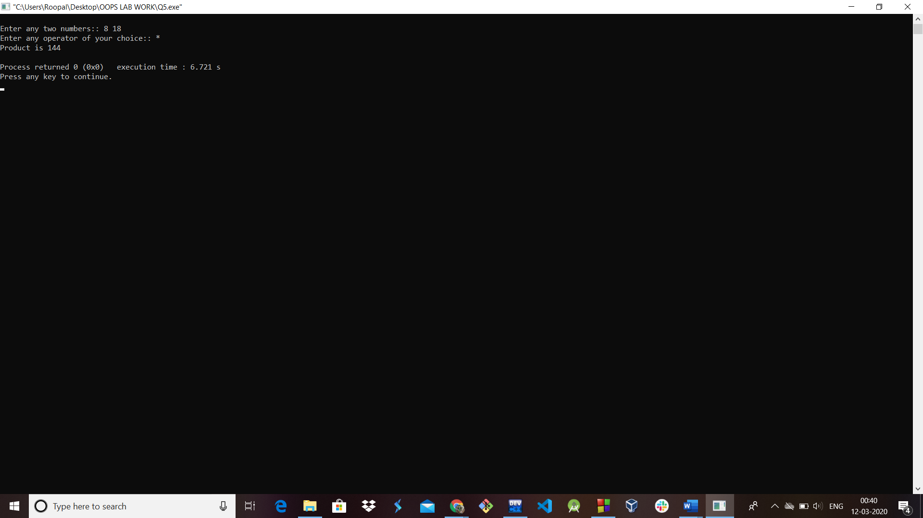

**Ques 6:** Write a program to perform the following conversions (and vice versa)

(a) Temperature in Celsius to Fahrenheit.

**Solution 6(a):**

#include<iostream>

using namespace std;

int main ()

{

float a, b;

int choice;

char ch;

cout<<"**** MENU ****\n";

cout<<"\n1. Convert from Celsius to Fahrenheit";

cout<<"\n2. Convert from Fahrenheit to Celsius\n";

do

{

cout<<"\n Enter your choice: ";

cin>>choice;//Entering choice

switch(choice)

{

case 1: cout<<"Enter temperature in Celsius: ";

cin>>a;

b=(a*9/5) + 32;

cout<<"Temperature in Fahrenheit is: "<<b;

break;

case 2: cout<<"Enter temperature in Fahrenheit: ";

cin>>a;

b=((a-32) *5)/9;

cout<<"Temperature in Celsius is: "<<b;

break;

default: cout<<"Wrong choice";

}

cout<<"\n\n Press 'y' to continue and any other integer to exit: ";

cin>>ch;

} while(ch=='y');

return 0;

}

**Output:**

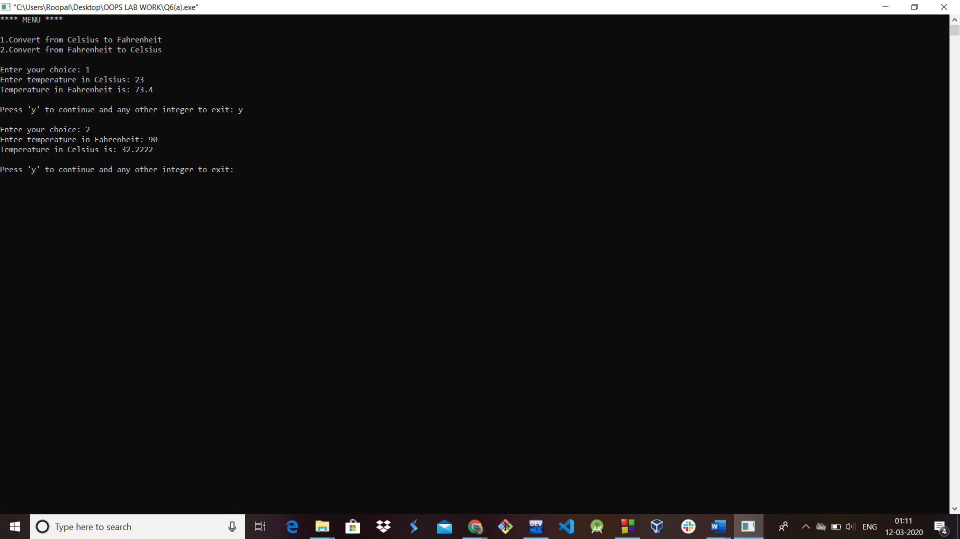

(b) Height in Centimetres to Feet and Inches.

**Solution 6(b):**

#include<iostream>

using namespace std;

int main ()

{

float a, b;

int choice;

char ch;

cout<<"**** MENU ****\n";

cout<<"\n1. Convert from Centimeters to Feet";

cout<<"\n2. Convert from Centimeters to Inches";

cout<<"\n3. Convert from Feet to Centimeters";

cout<<"\n4. Convert from Inches to Centimeters\n";

do

{

cout<<"\n Enter your choice(1-4): ";

cin>>choice;//Entering choice

switch(choice)

{

case 1: cout<<"Enter height (in cm): ";

//cm refers to Centimeter

cin>>a;

b=a/30.48;

cout<<"Height in Feet is: "<<b;

break;

case 2: cout<<"Enter height (in cm): ";

//cm refers to Centimeter

cin>>a;

b=a/ 2.54;

cout<<"Height in Inches is: "<<b;

break;

case 3: cout<<"Enter height (in Feet): ";

cin>>a;

b=a*30.48;

cout<<"Height in cm is: "<<b;

break;

case 4: cout<<"Enter height (in Inches): ";

cin>>a;

b=a*2.54;

cout<<"Height in cm is: "<<b;

break;

default: cout<<"Wrong choice";

}

cout<<"\n Press 'y' to continue and any other integer to exit: ";

cin>>ch;

} while(ch=='y');

return 0;

}

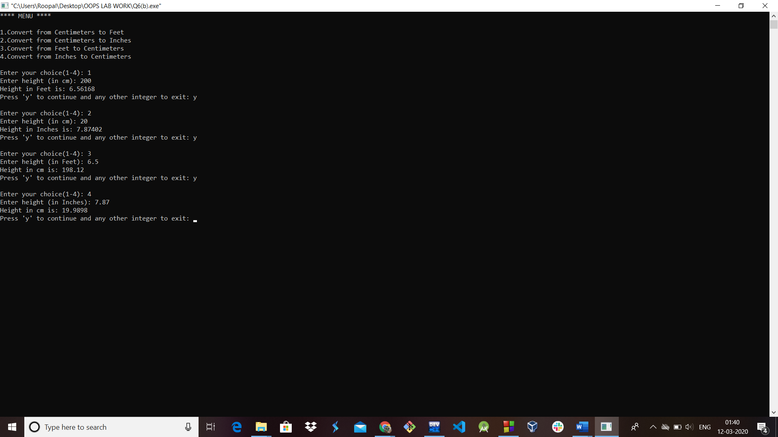

**Ques 7:** A perfect number is the one whose divisors add up to the number. For example, 6 is a perfect number because 6=1+2+3. Write a program that prints all perfect numbers from 1 till 10000.

**Solution 7:**

//program to find perfect numbers between 1-1000

#include<iostream>

using namespace std;

int main ()

{

int j=1;

//Initializing number to be checked as 1

cout<<"Perfect numbers between 1-10000 are as follows:\n";

do {

int sum=0;

for (int i=1; i<j; i++)

{

if (j%i ==0)

sum+=i;

}

//checking sum equal or not

if(sum==j)

cout<<j<<" ";

j++;

} while(j<=10000);

//end of while loop

return 0;

}

**Output:**

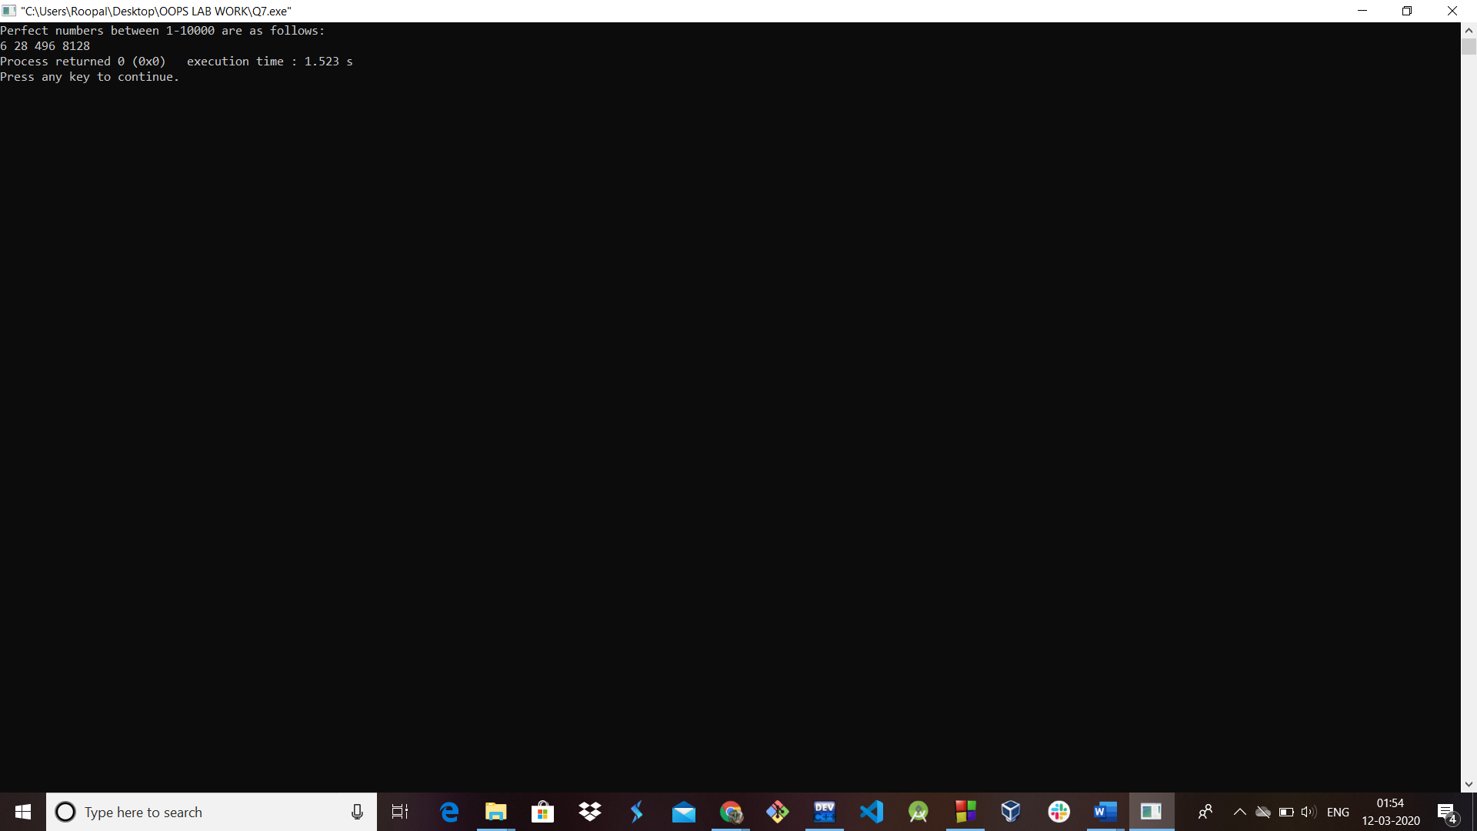

**Ques 8:** Write a program to swap two numbers: using call by value and cal by reference & pointer.

**Solution 8:**

//swapping using call by value and call by reference

#include<iostream>

using namespace std;

int swap (int a, int b)

{

int t=a;

a=b;

b=t;

}

int swap1(int *a, int *b)

{

int t=*a;

*a=*b;

*b=t;

}

int main ()

{

int a, b;

cout<<"Enter a and b::";

cin>>a>>b;

cout<<"Value of a and b before swapping:: "<<a<<" "<<b<<endl;

cout<<"\n After swapping: ";

cout<<"\n Values of a and b using call by value:: ";

swap (a, b);

cout<<a<<" "<<b;

cout<<"\n Values of a and b using call by reference:: ";

swap1(&a, &b);

cout<<a<<" "<<b;

return 0;

}

**Output:**

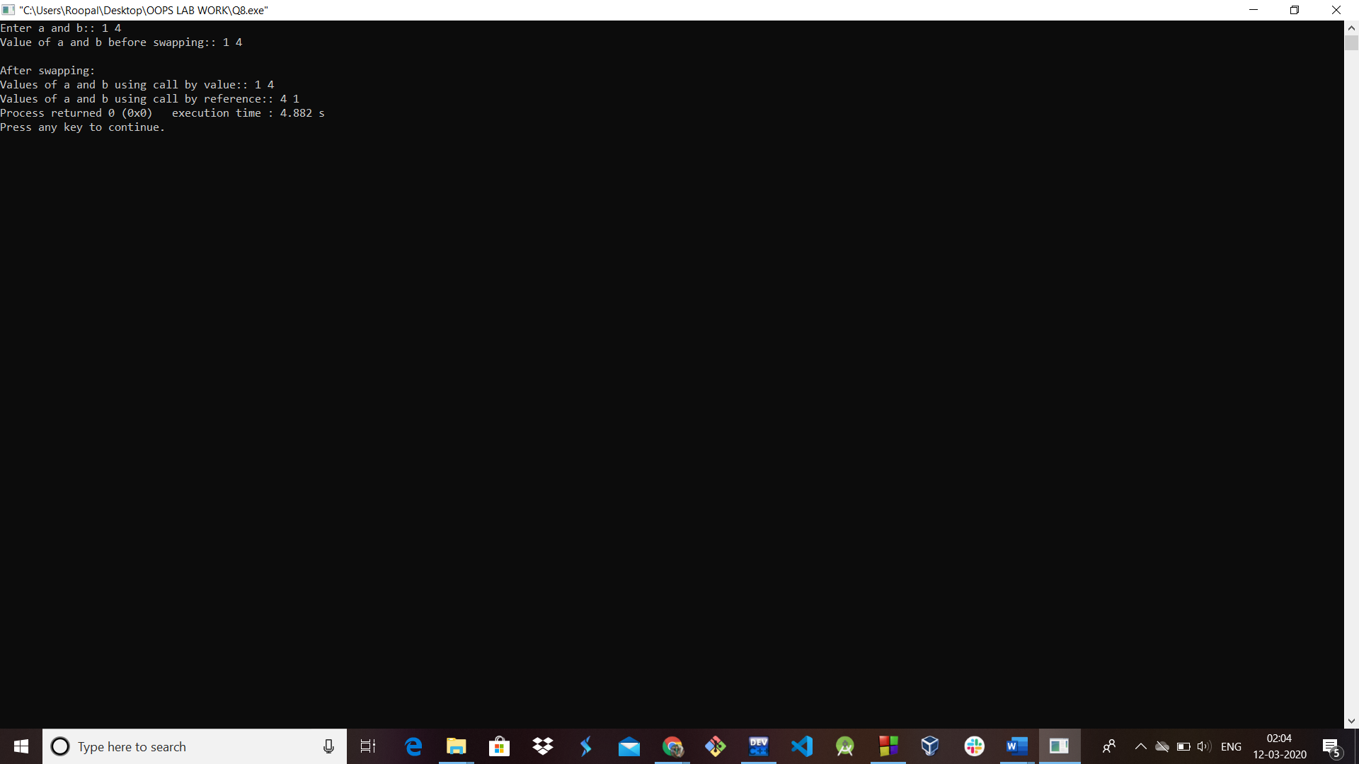

**Ques 9:** Write a program that calculates area and perimeter of the following geometric figures. Your program should use *function overloading* and each function should take as inputs the required arguments (without constraining the user) and return both area and perimeter.

(a) Square

(b) Rectangle

**Solution 9:**

#include<iostream>

using namespace std;

float area (float side) {

return side*side;

}

float area (float len, float bre) {

return len*bre;

}

float peri (float side) {

return 4*side;

}

float peri (float len, float bre) {

return 2*(len+ bre);

}

int main ()

{

float s, l, b;

cout<<"Enter side of square: ";

cin>>s;

cout<<"Enter length and breadth of rectangle: ";

cin>>l>>b;

cout<<"\n Area of Square = "<<area(s);

cout<<"\n Perimeter of Square = "<<peri(s);

cout<<"\n Area of Rectangle = "<<area (l, b);

cout<<"\n Perimeter of Rectangle = "<<peri (l, b);

return 0;

}

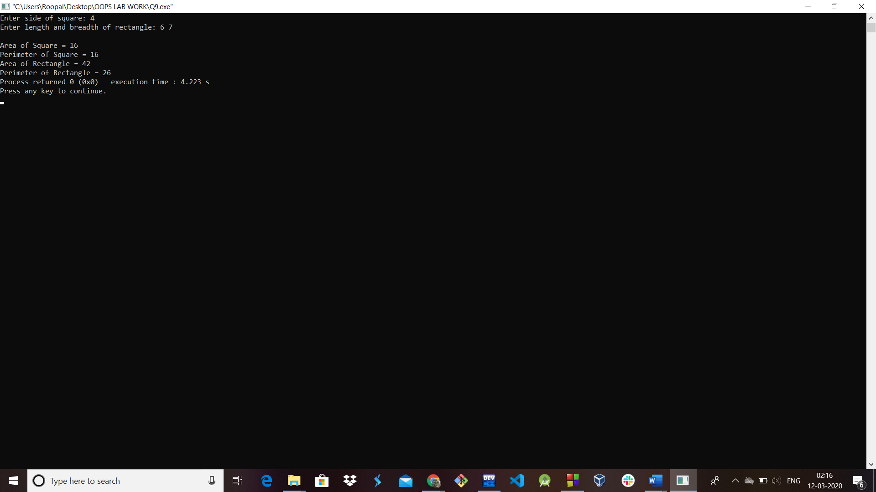

**Ques 10:** Write a program with *recursive functions* that perform the following:

(a) Reverse an input string

**Solution 10(a):**

#include <iostream>

#include <cstring>

using namespace std;

//recursive function for reversing the string.

void reverse (char *x, int begin, int end)

{

char c;

if (begin >= end)

return;

c = *(x+ begin);

*(x+ begin) = *(x+ end);

*(x+ end) = c;

reverse (x, ++begin, --end);

}

int main ()

{

char a[100];

cout<<"Enter a string: ";

cin>>a;

//function call

reverse (a, 0, strlen(a)-1);

cout<<"Reversed string is: "<<a;

return 0;

}

**Output:**

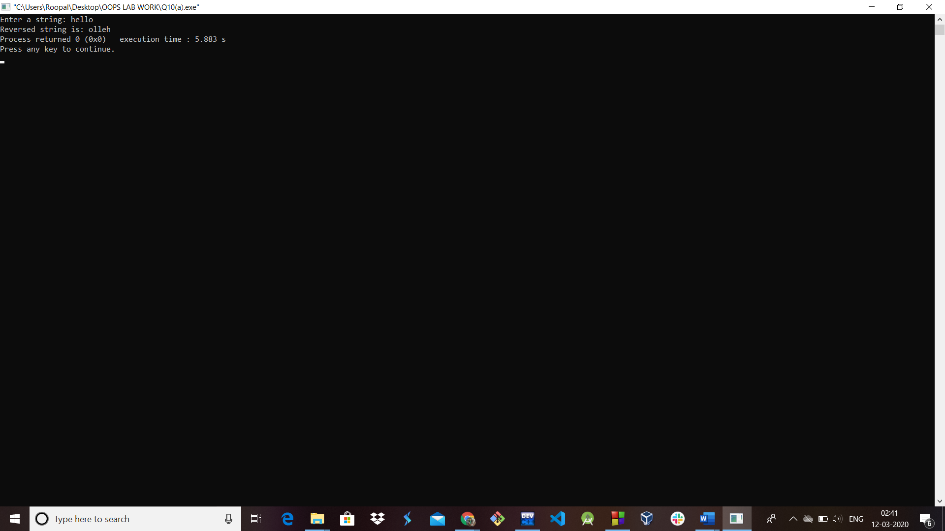

(b) Check if an input string is palindrome or not.

**Solution 10(b):**

#include <iostream>

#include <string.h>

using namespace std;

//recursive function for palindrome check.

bool isPalindrome (const string &str, int start, int end)

{

if (start >= end)

return true;

if (str[start] != str[end])

return false;

return isPalindrome (str, ++start, --end);

}

int main ()

{

char str[20];

int flag = 0;

cout<<"Enter a string: ";

cin>>str;

//to find length of the string

int len = strlen(str)-1;

if (isPalindrome (str, 0, len)) //function call

cout << str << " is a Palindrome." << endl;

else

cout << str << " is not a Palindrome." << endl;

return 0;

}

**Output:**

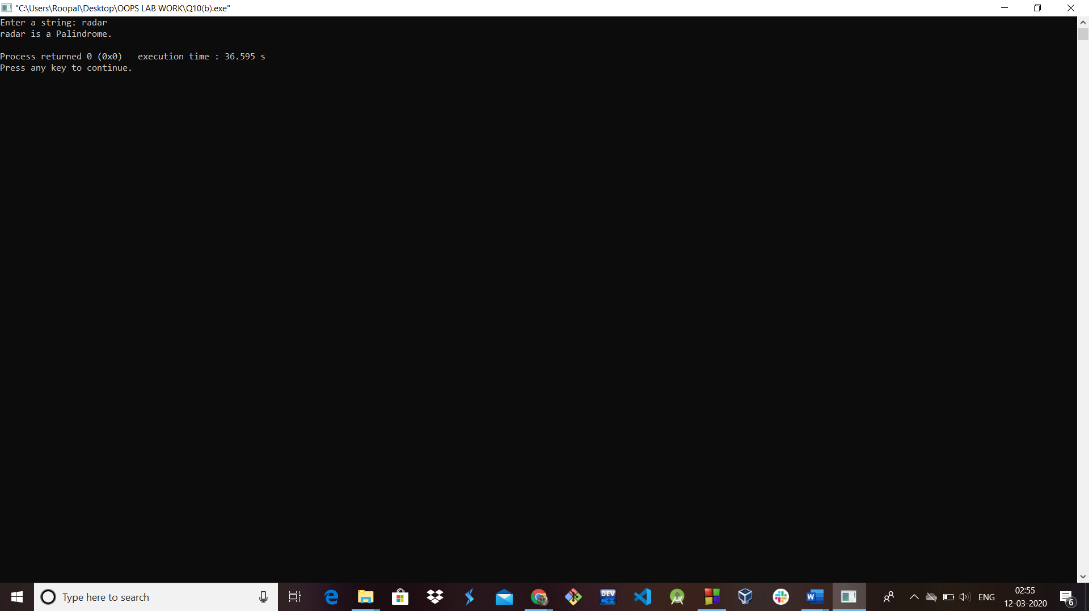

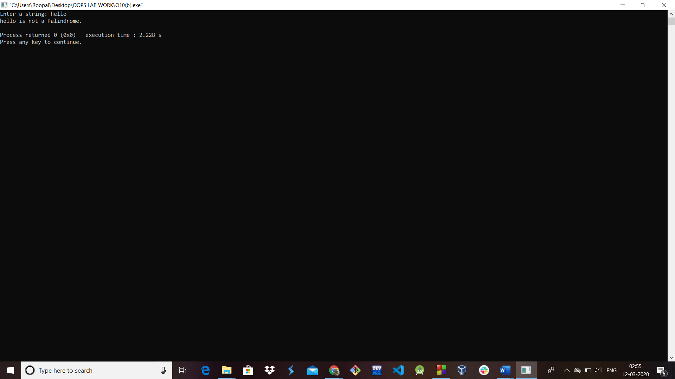

**Ques 11:** What are the different ways in which objects of a class can be created? Explain with an illustrative program for each

**Solution 11:**

1. Using *new* keyword

#include <iostream>

#include<stdlib.h>

using namespace std;

class Shape{

public:

    Shape() //default

    {

        cout<<"Default Constructor"<<endl;

    }

    Shape(const Shape& obj) //copy constructor

    {

        cout<<"Copy Constructor"<<endl;

    }

    void * operator new(size_t size) //operator overloading

    {

        cout<<"New ";

        void * storage=malloc(size);

        if(NULL == storage)

        {

            cout<<"Allocation fail : no free memory";

        }

    return storage;

}

};

int main()

{

Shape *ptrShape=new Shape();

Shape *ptrShapeOver= new Shape();

return 0;

}

**Output:**

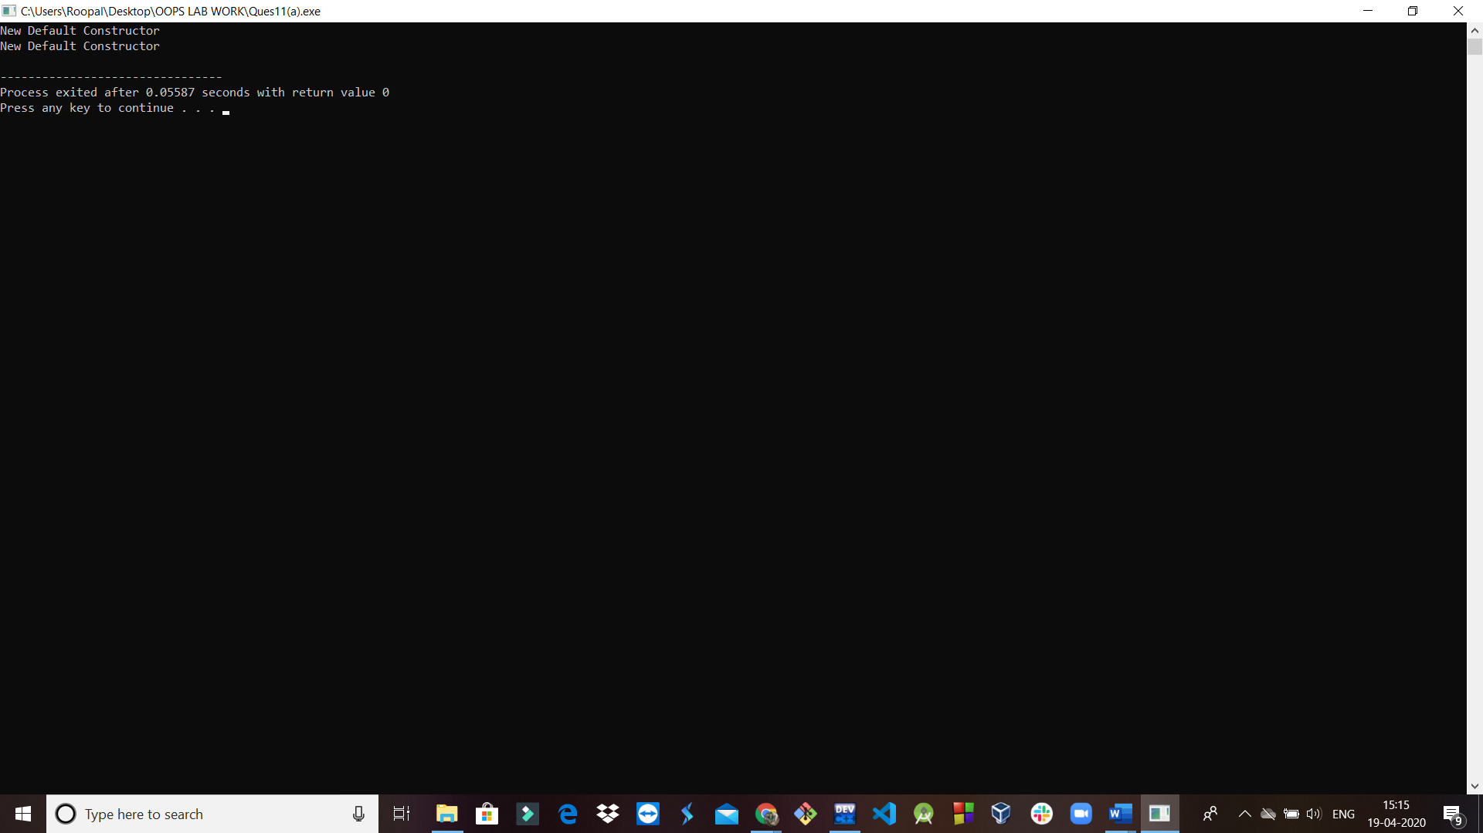

1. Using the class name

#include <iostream>

#include<conio.h>

#include<stdlib.h>

using namespace std;

class Shape{

public:

    Shape() //default

    {

        cout<<"Default Constructor"<<endl;

    }

    Shape(const Shape& obj) //copy constructor

    {

        cout<<"Copy Constructor"<<endl;

    }

    void * operator new(size_t size) //operator overloading

    {

cout<<"New ";

void * storage=malloc(size);

if(NULL == storage){

cout<<"Allocation fail : no free memory";

}

     return storage;

}

};

int main()

{

Shape obj;

Shape obj2=obj;

Shape obj3(obj);

Shape *ptrShape=new Shape();

Shape *ptrShapeOver= new Shape(obj3);

return 0;

}

**Output:**

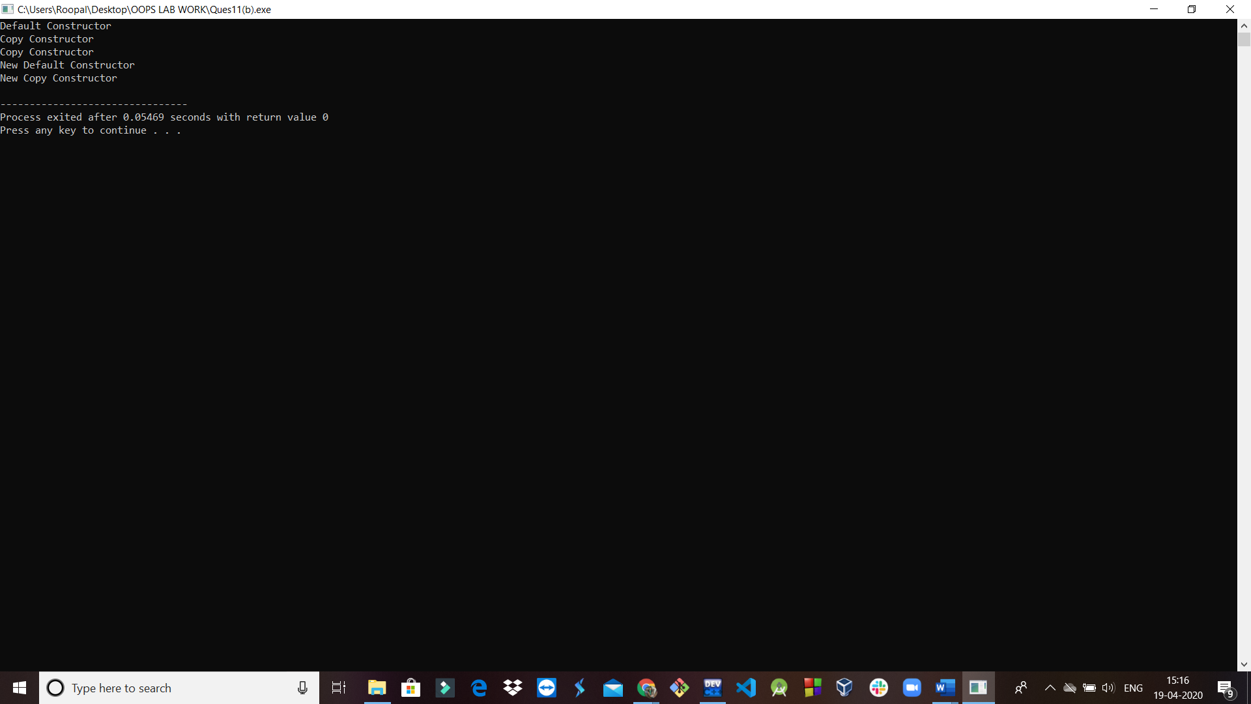

**Ques 12:** Write a program that illustrates the use of

**a) Inline function**

**Solution 12(a):**

#include <iostream>

using namespace std;

inline int cube(int s)

{

return s*s*s;

}

int main()

{

cout << "The cube of 3 is: " << cube(3) << "\n";

return 0;

}

**Output:**

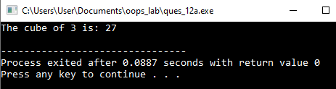

**b) Function with default argument**

**Solution 12(b):**

#include<iostream>

using namespace std;

// A function with default arguments, it can be called with

// 2 arguments or 3 arguments or 4 arguments.

int sum(int x, int y, int z=0, int w=0)

{

    return (x + y + z + w);

}

int main()

{

cout << sum(10, 15) << endl;

cout << sum(10, 15, 25) << endl;

cout << sum(10, 15, 25, 30) << endl;

return 0;

}

**Output:**

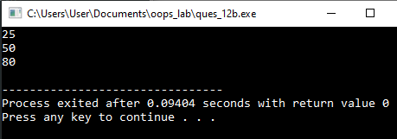

**Ques 13:** Write a program that illustrates:

**(a) Use of friend function**

**Solution 13(a):**

#include <iostream>

using namespace std;

class Number

{private:

         int a;

     public:

         void getNum(int x);

         friend void printNum(Number NUM);

};

 void Number::getNum(int x){

=x; }

void printNum(Number NUM){

cout << "Value of a (private data member of class Number): ";

cout << NUM.a;

 }

 int main()

{

Number nObj; //Object declaration

nObj.getNum(1000);

printNum(nObj);

return 0;

}

**Output:**

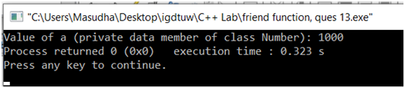

**(b)Member function as a friend function**

**Solution 13(b):**

#include<iostream>

using namespace std;

class B; //declare class B

class A {

private:

int a;

public:

//constructor

A(int a){

     this->a = a;

}

friend int max(A a, B b);

};

class B {

private:

int b;

public:

//constructor

B(int b) {

     this->b = b;

}

  friend int max(A a, B b);

};

int max(A a, B b) {

return (a.a > b.b ? a.a : b.b);

}

int main()

{

A a(10);

B b(15);

cout << "Greatest is : " << max(a, b);

return 0;

}

**Output:**

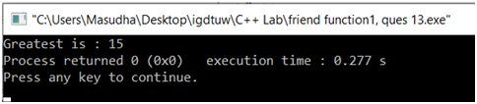

**Ques 14:** Account database is maintaining details of customers. Design suitable class and write member functions which provide the following functions:

(a)Insert details of customer

(b) Search an existing customer w.r.t. account no.

(c) Modify the details of an existing customer

**Solution 14:**

#include<iostream>

using namespace std;

class account

{

public:

     int   cust_num;

     char  cust_name[20];

     long long int phone;

void insert_details();

void search_details();

void modify_details();

void show_details();

};

void account :: insert_details()

{

cout<<"\nEnter customer number:\n";

cin>>cust_num;

cout<<"\nEnter customer name:\n";

cin>>cust_name;

cout<<"\nEnter customer phone number:\n";

cin>>phone;

}

void account :: show_details()

{

cout<<"\nThe customer details are as follows\n";

cout<<cust_num<<"\t"<<cust_name<<"\t"<<phone;

}

void account :: search_details()

{

int search_customer;

cout<<"\nEnter the customer number that you want to search\n";

cin>>search_customer;

if(search_customer==cust_num)

{

         cout<<"\nCustomer found\n";

}

}

void account:: modify_details()

{

int search_customer;

cout<<"Enter the customer number that you want to search";

cin>>search_customer;

if(search_customer==cust_num)

{

         cout<<"Enter the choice number, what you want to change\n";

cout<<"1. Customer Name\n";

cout<<"2. Phone Number\n";

int choice=-1;

cin>>choice;

switch(choice)

{

case 1: cout<<"Enter new name";

cin>>cust_name;

break;

case 2: cout<<"Enter new phone number";

cin>>phone;

break;

default: cout<<"Invalid choice.";

break;

}

}

}

int main()

{

account a[10];

int i,num;

cout<<"\nEnter number of employee details\n";

cin>>num;

for(i=0;i<num;i++)

a[i].insert_details();

for(i=0;i<num;i++)

a[i].show_details();

for(i=0;i<num;i++){

a[i].search_details();

break;

}

for(i=0;i<num;i++){

a[i].modify_details();

break;

}

for(i=0;i<num;i++)

a[i].show_details();

return 0;

}

**Output:**

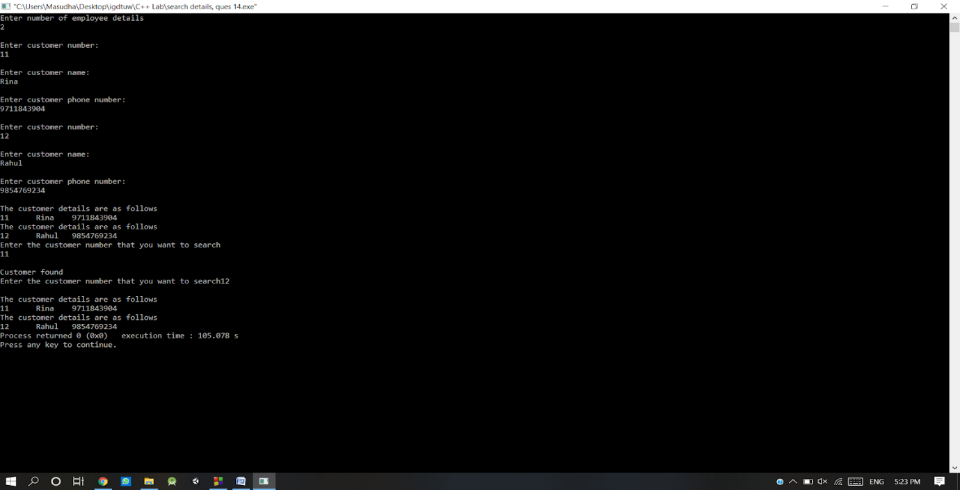

**Operator Overloading**

**Ques 15:** Write a program which provides concrete representation for the concept of complex numbers. Using *operator overloading,* perform the operations of addition and multiplication of two given complex numbers. Implement operator overloading.

**Solution 15:**

#include<iostream>

 using namespace std;

class complex

 {

int i,r;

  public:

void read(){

         cout<<"\nEnter Real Part:";

     cin>>r;

         cout<<"Enter Imaginary Part:";

     cin>>i;

}

  void display(){

         cout<<"\n= "<<r<<"+"<<i<<"i";

}

complex operator+(complex a2){

complex a;

a.r=r+a2.r;

a.i=i+a2.i;

return a;

}

complex operator*(complex a2){

complex a;

a.r=(r*a2.r)-(i*a2.i);

a.i=(r*a2.i)+(i*a2.r);

return a;

}

 };

 int main()

 {

int ch;

complex a,b,c;

do

{

cout<<"\n1.Addition";

cout<<" 2.Mulitplication 3.Exit\n";

cout<<"\nEnter the choice :";

cin>>ch;

switch(ch)

{

case 1: cout<<"\nEnter The First Complex Number:";

a.read();

a.display();

cout<<"\nEnter The Second Complex Number:";

b.read();

b.display();

c=a+b;

cout<<"\nThe sum is ";

c.display();

break;

case 2: cout<<"\nEnter The First Complex Number:";

a.read();

a.display();

cout<<"\nEnter The Second Complex Number:";

b.read();

b.display();

c=a*b;

cout<<"\nThe product is ";

c.display();

break;

case 3: break;

default: cout<<"Invalid choice";

break;

}

}while(ch!=5);

return 0;

}

**Output:**

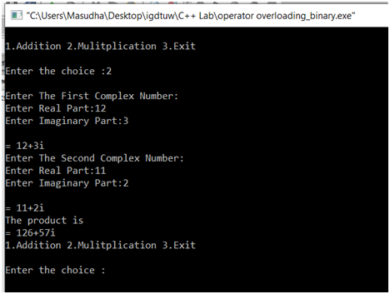

**Ques 16:** Extend the concept of complex number by providing provisions for unary operators + and – which increments and decrements both real and imaginary part of complex numbers by 1, respectively. Implement operator overloading.

**Solution 16:**

#include<iostream>

 using namespace std;

class complex

{

int a,b,c;

public:

     complex(){}

     void getvalue(){

cout<<"Enter the real part: ";

cin>>a;

cout<<"Enter the imaginary part: ";

cin>>b;

     }

     void operator++(){

         a=++a;

         b=++b;

     }

     void operator--(){

         a=--a;

         b=--b;

     }

    void display(){

             cout<<a<<"+"<<b<<"i"<<endl;

     }

};

int main(){

complex obj;

obj.getvalue();

++obj;

cout<<"Increment Complex Number\n";

obj.display();

--obj;

cout<<"Decrement Complex Number\n";

obj.display();

}

**Output:**

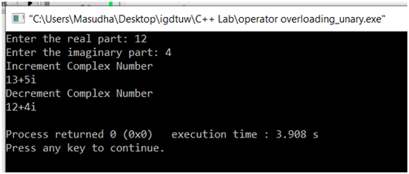

**Ques 17:** Write a program to overload the following operators:

**a) Subscript operator**

**Solution17(a):**

#include<iostream>

using namespace std;

const int SIZE=5;

class arraytype

{

int a[SIZE];

public:

arraytype()

{

int i;

for(i=0; i<SIZE; i++){

a[i]=i;

}

}

int operator[](int i){

return a[i];

}

};

int main()

{

arraytype ob;

int i;

for(i=0; i<SIZE; i++)

{

cout<<ob.operator[](i)<<" ";

cout<<ob[i]<<" ";

}

return 0;

}

**Output:**

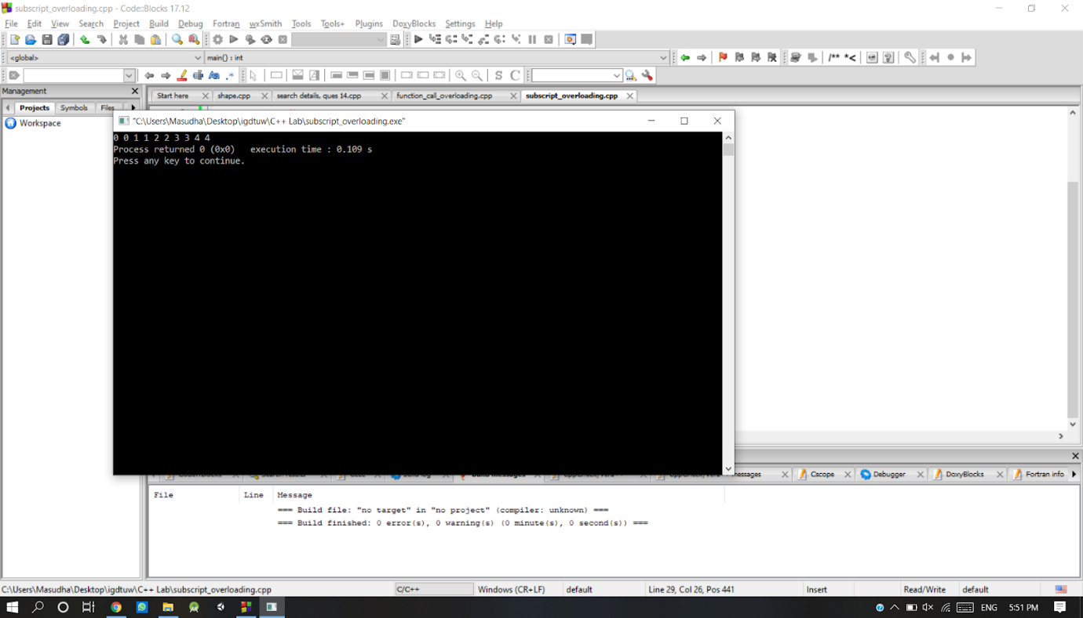

**b) Function call operator**

**Solution17(b):**

#include <iostream>

using namespace std;

class Distance {

    private:

       int feet;

       int inches;

    public:

       Distance() {

          feet = 0;

          inches = 0;

       }

       Distance(int f, int i) {

          feet = f;

          inches = i;

       }

       // overload function call

       Distance operator()(int a, int b, int c) {

          Distance D;

D.feet = a + c + 10;

D.inches = b + c + 100 ;

return D;

       }

       void displayDistance() {

          cout << "F: " << feet << " I:" << inches << endl;

       }

};

int main()   
{

Distance D1(11, 10), D2;

cout << "First Distance : ";

D1.displayDistance();

D2 = D1(10, 10, 10); // invoke operator()

cout << "Second Distance :";

D2.displayDistance();

return 0;

}

**Output:**

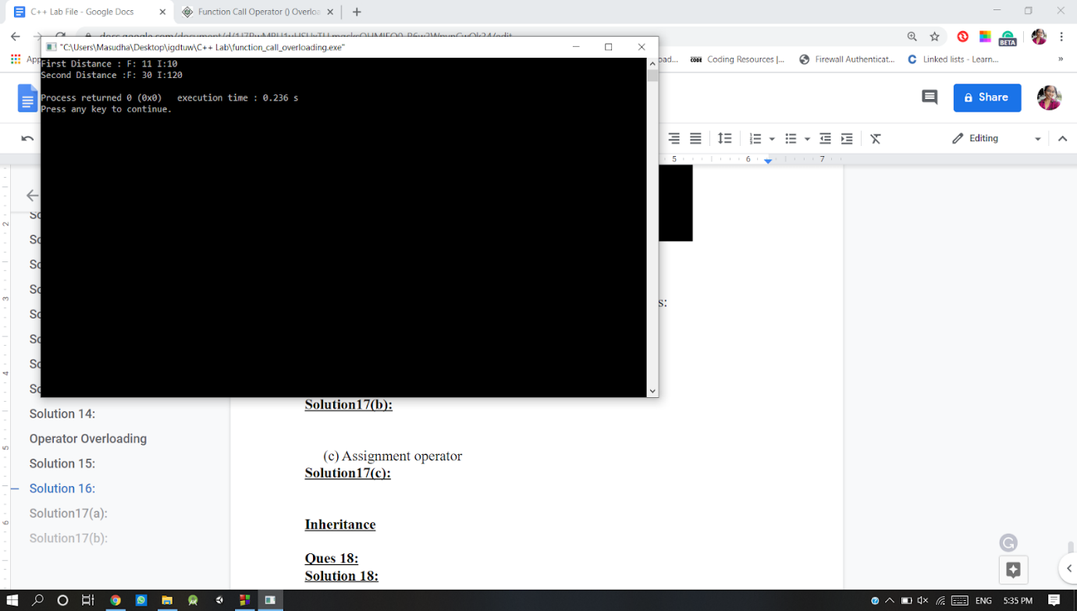

**c) Assignment operator**

**Solution17(c):**

#include<iostream>

using namespace std;

class coord

{

     int x, y;

public:

coord(){

x=0; y=0;

}

coord(int i, int j){

x=i; y=j;

}

int operator==(coord ob2);

};

int coord::operator==(coord ob2)

{

     return((x==ob2.x)&&(y==ob2.y));

}

int main()

{

coord o1(10,10), o2(5,3), o3(10,10), o4(0,0);

if(o1==o2)

cout<<"O1 is same as O2"<<endl;

else

cout<<"Not same"<<endl;

if(o1==o3)

cout<<"O1 is same as O3";

else

cout<<"Not same";

return 0;

}

**Output:**

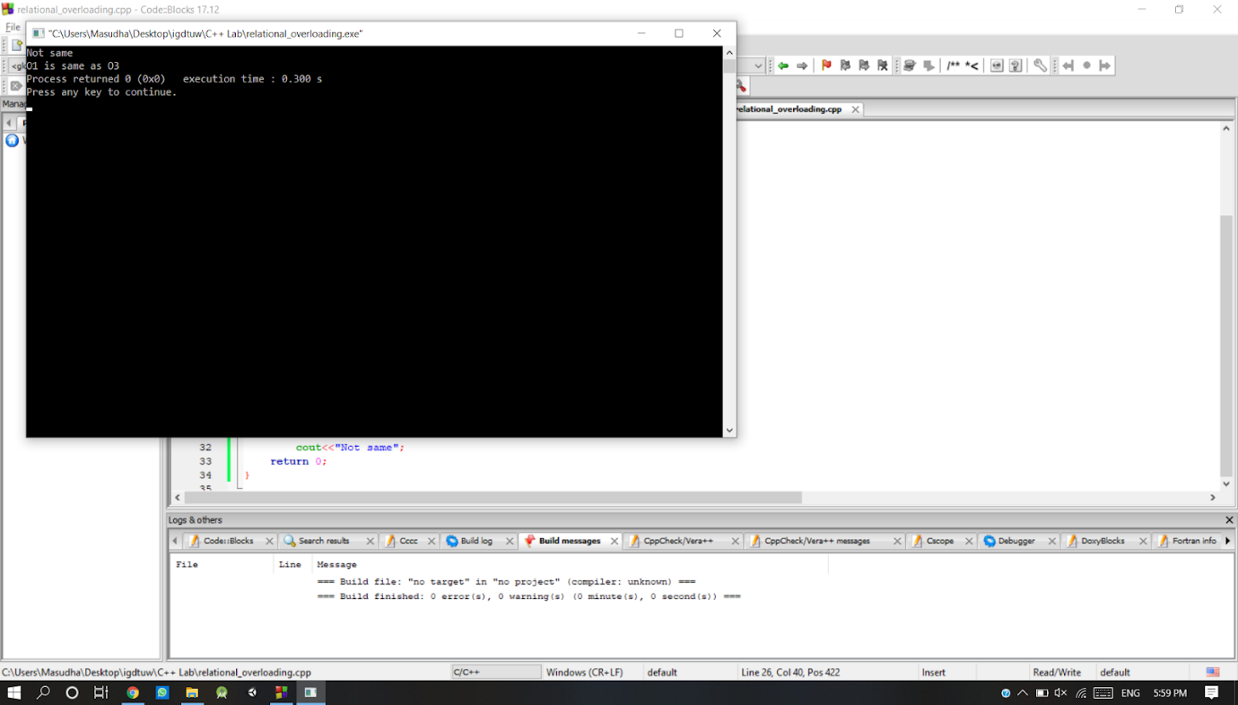

**Inheritance**

**Ques 18:** Write a C++ program that represents a Vehicle-Car and Vehicle-Motorcycle relationship C++ program should provide following operations.

1. Add a vehicle (car/motorcycle)
2. Design the vehicles (including both cars and motorcycles) with  respect to their registration ID (alpha-numeric)

**Solution 18:**

#include<iostream>

#include<string>

using namespace std;

class Vehicle

{

public:

char vehiclename[10];

int registrationID;

char model[10];

int year;

void addVehicle()

{

cout<<"Enter the registration ID: ";

cin>>registrationID;

cout<<"Enter the vehicle name: ";

cin>>vehiclename;

cout<<"Enter the model: ";

cin>>model;

cout<<"Enter the year: ";

cin>>year;

}

void display()

{

cout<<"Registration ID: "<<registrationID<<" Vehicle is: "<<vehiclename<<" Model: "<<model<<" Year: "<<year<<endl;

}

};

class Car : public Vehicle

{

public:

void carDetails(){

cout<<"Car Details are as follows"<<endl;

}

};

class Motorcycle : public Vehicle

{

public:

void motorcycleDetails(){

cout<<"**********List of Motorcycles***************"<<endl;

}

};

int main()

{

cout<<"*********ADD VEHICLE***************"<<endl;

string answer;

cout<<"Do you want to add a car or motorcycle?"<<endl;

getline(cin, answer);

if(answer == "car"){

int n;

cout<<"How many cars you want to add? ";

cin>>n;

//car

Car c[n];

for(int i=0; i<n; i++){

c[i].addVehicle();

}

for(int i=0; i<n; i++){

c[i].display();

}

}

else{

int n;

cout<<"How many motorcycles you want to add? ";

cin>>n;

//car

Motorcycle m[n];

for(int i=0; i<n; i++){

m[i].addVehicle();

}

for(int i=0; i<n; i++){

m[i].display();

}

}

return 0;

}

**Output:**

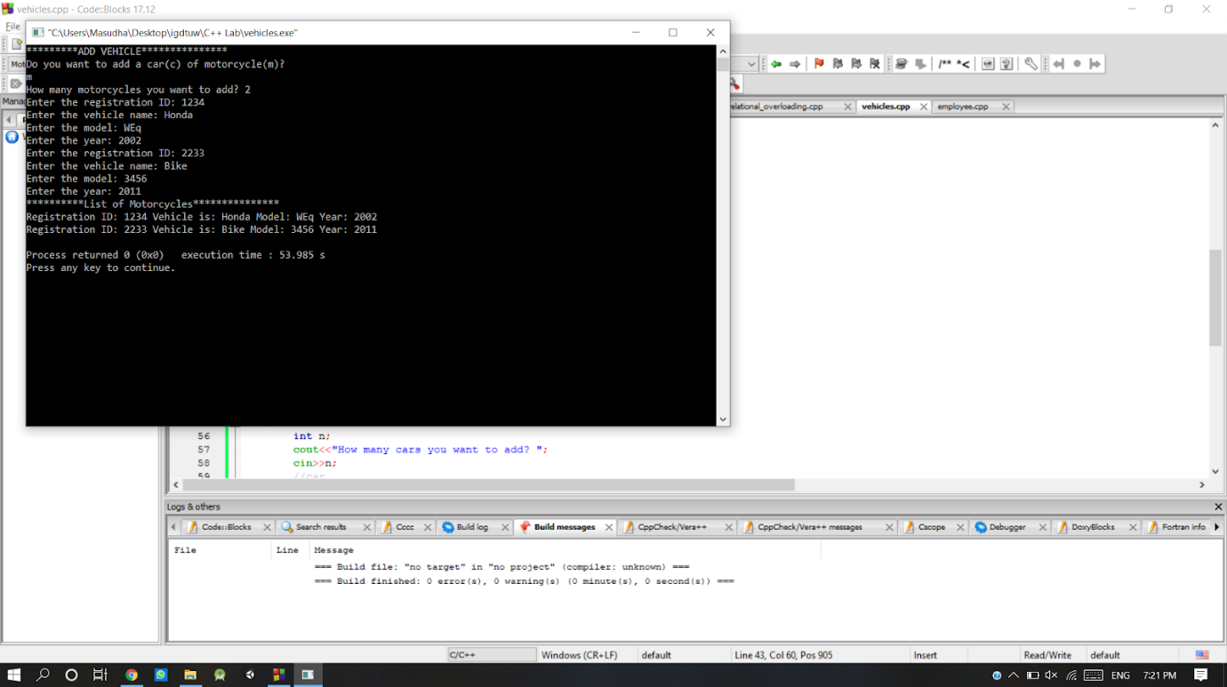

**Ques 19:** Design a single C++ program illustrating the following concept of inheritance:

**a) Single Inheritance**

**Solution 19(a):**

#include <iostream>

using namespace std;

class base    //single base class

{

    public:

      int x;

    void getdata(){

     cout << "Enter the value of x = "; cin >> x;

    }

};

class derive : public base    //single derived class

{

private:

int y;

public:

void readdata(){

cout << "Enter the value of y = "; cin >> y;

}

void product(){

cout << "Product = " << x * y;

}

 };

 int main()

 {

derive a;     //object of derived class

a.getdata();

a.readdata();

a.product();

return 0;

 }

**Output:**

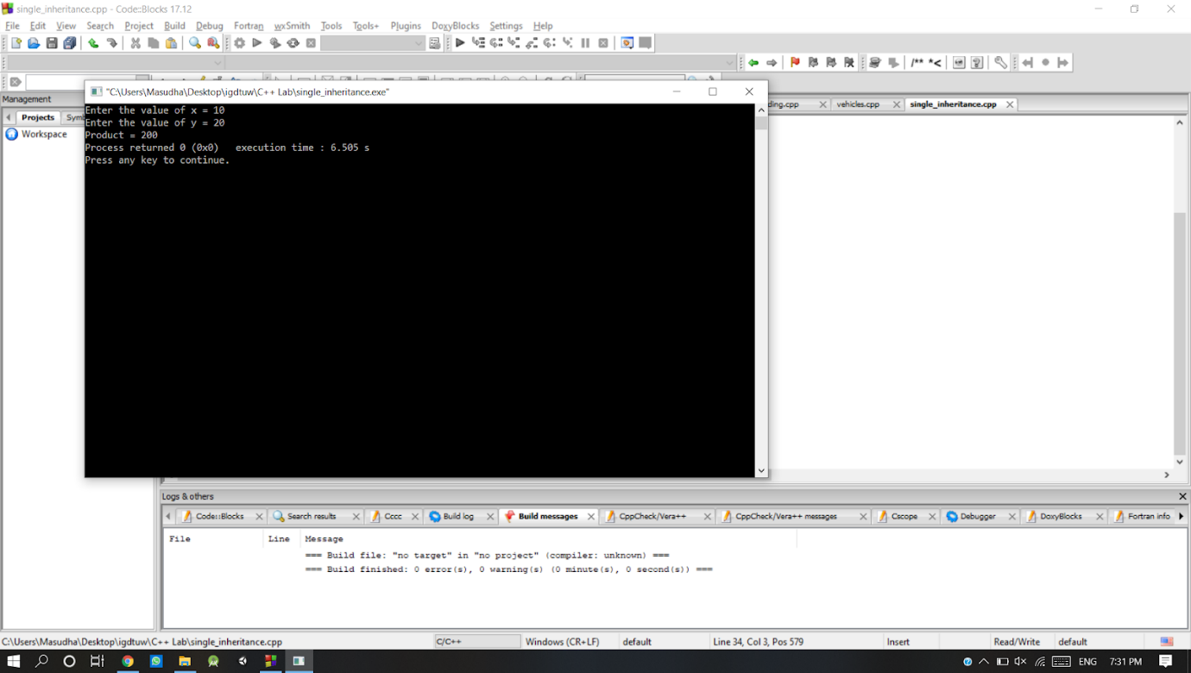

**b) Multiple Inheritance**

**Solution 19(b):**

#include<iostream>

using namespace std;

class A

{

  public:

  int x;

  void getx()

{

  cout << "enter value of x: "; cin >> x;

     }

};

class B

{

  public:

  int y;

  void gety(){

      cout << "enter value of y: "; cin >> y;

  }

};

class C : public A, public B   //C is derived from class A and class B

{

  public:

  void sum(){

      cout << "Sum = " << x + y;

  }

};

int main(){

  C obj1; //object of derived class C

  obj1.getx();

  obj1.gety();

  obj1.sum();

  return 0;

}

**Output:**

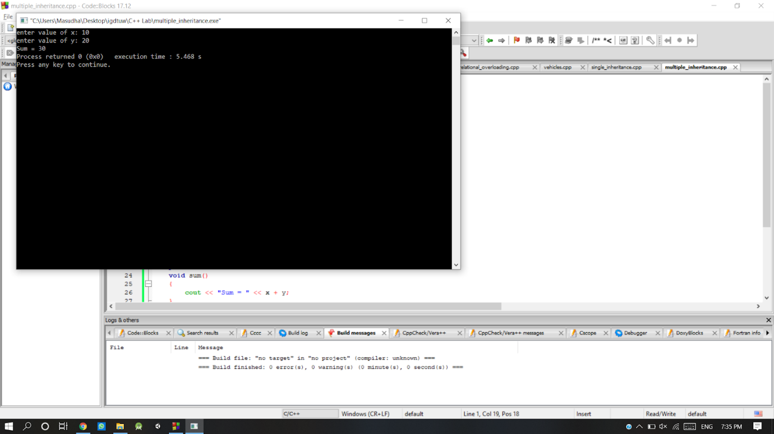

**c) Multi-level Inheritance**

**Solution 19(c):**

#include <iostream>

using namespace std;

class base //single base class

{

  public:

  int x;

  void getdata(){

     cout << "Enter value of x= "; cin >> x;

  }

};

class derive1: public base // derived class from base class

{

  public:

  int y;

  void readdata(){

      cout << "\nEnter value of y= "; cin >> y;

  }

};

class derive2: public derive1   // derived from class derive1

{

  private:

  int z;

  public:

  void indata(){

     cout << "\nEnter value of z= "; cin >> z;

  }

  void product(){

      cout << "\nProduct= " << x * y * z;

  }

};

int main()

{

derive2 a;      //object of derived class

a.getdata();

a.readdata();

a.indata();

a.product();

return 0;

}

**Output:**

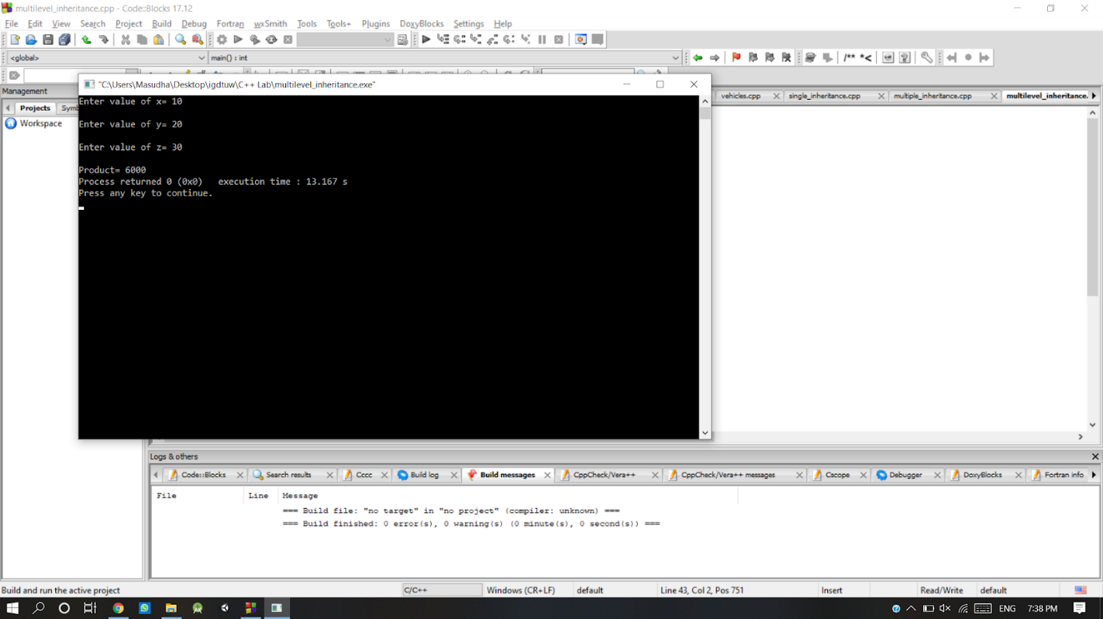

**Ques 20:** Design a single C++ program illustrating the following concept of inheritance:

**a) Public Derivation**

**Solution 20 (a):**

#include <iostream>

using namespace std;

// Base class

class Shape {

    public:

void setWidth(int w) {

width = w;

}

void setHeight(int h) {

height = h;

}

protected:

int width;

int height;

};

// Derived class

class Rectangle: public Shape {

    public:

       int getArea() {

          return (width * height);

       }

};

int main(void) {

Rectangle Rect;

Rect.setWidth(5);

Rect.setHeight(7);

// Print the area of the object.

cout << "Total area: " << Rect.getArea() << endl;

return 0;

}

**Output:**

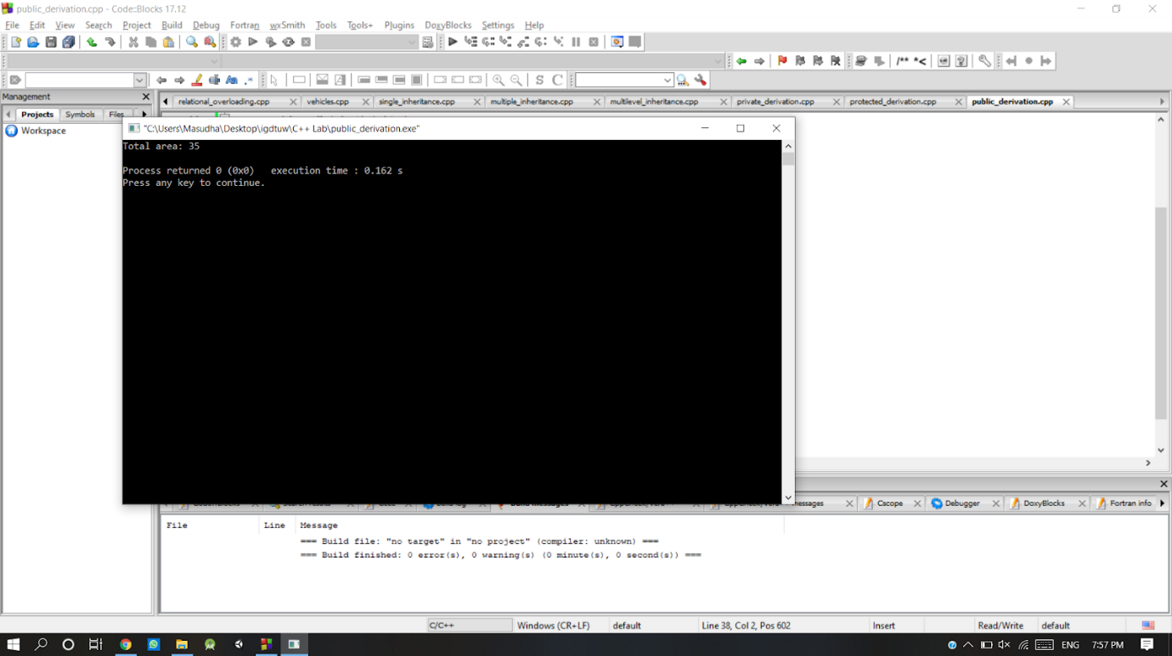

**b) Private Derivation**

**Solution 20 (b):**

#include <iostream>

using namespace std;

class Parent{

public:

void parentMethod( void ){

cout<<"Inside parent method"<<endl;}

};

class Child : private Parent{

public:

void childMethod( void){

cout<<"Inside child method"<<endl;

parentMethod();

}

};

int main( void )

{

   Child C;

   C.childMethod();

   return 0;

}

**Output:**

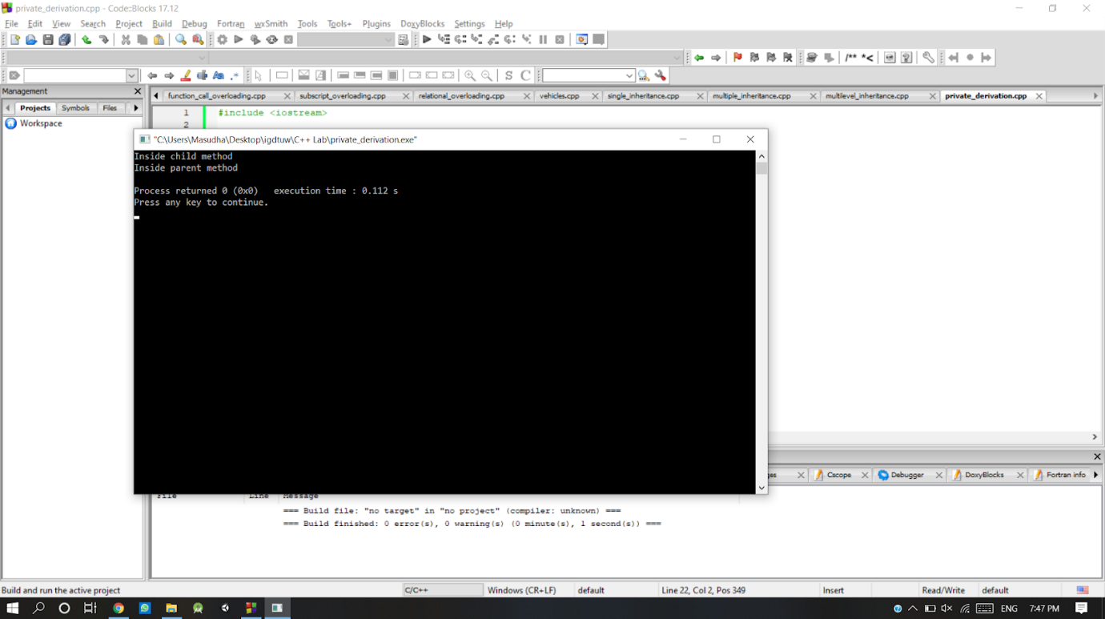

**c) Protected Derivation**

**Solution 20 (c):**

#include <iostream>

using namespace std;

class GrandParent{

public:

void grandParentMethod( void ){

cout<<"Method in the grand parent class"<<endl; }

};

class Parent : protected GrandParent{

public:

void parentMethod( void ){

cout<<"Method in the parent class"<<endl;

}

};

class Child: protected Parent{

public:

void

childMethod( void ){

cout<<"Method in the child class"<<endl;

parentMethod();

grandParentMethod();

}

};

int main( void )

{

Child C;

C.childMethod();

return 0;

}

**Output:**

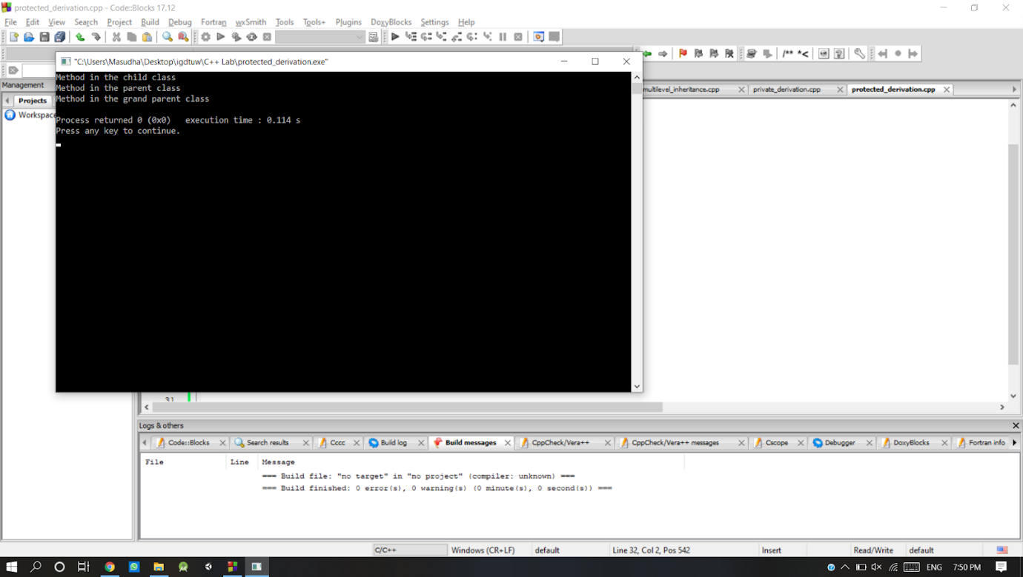

**Ques 21:** Write a C++ program that illustrates the use of virtual base class.

**Solution 21:**

#include <iostream>

using namespace std;

class A {

public:

int a;

A() // constructor

{

a = 10;

}

};

class B : public virtual A {

};

class C : public virtual A {

};

class D : public B, public C {

};

int main()

{

D object; // object creation of class d

cout << "a = " << object.a << endl;

return 0;

}

**Output:**

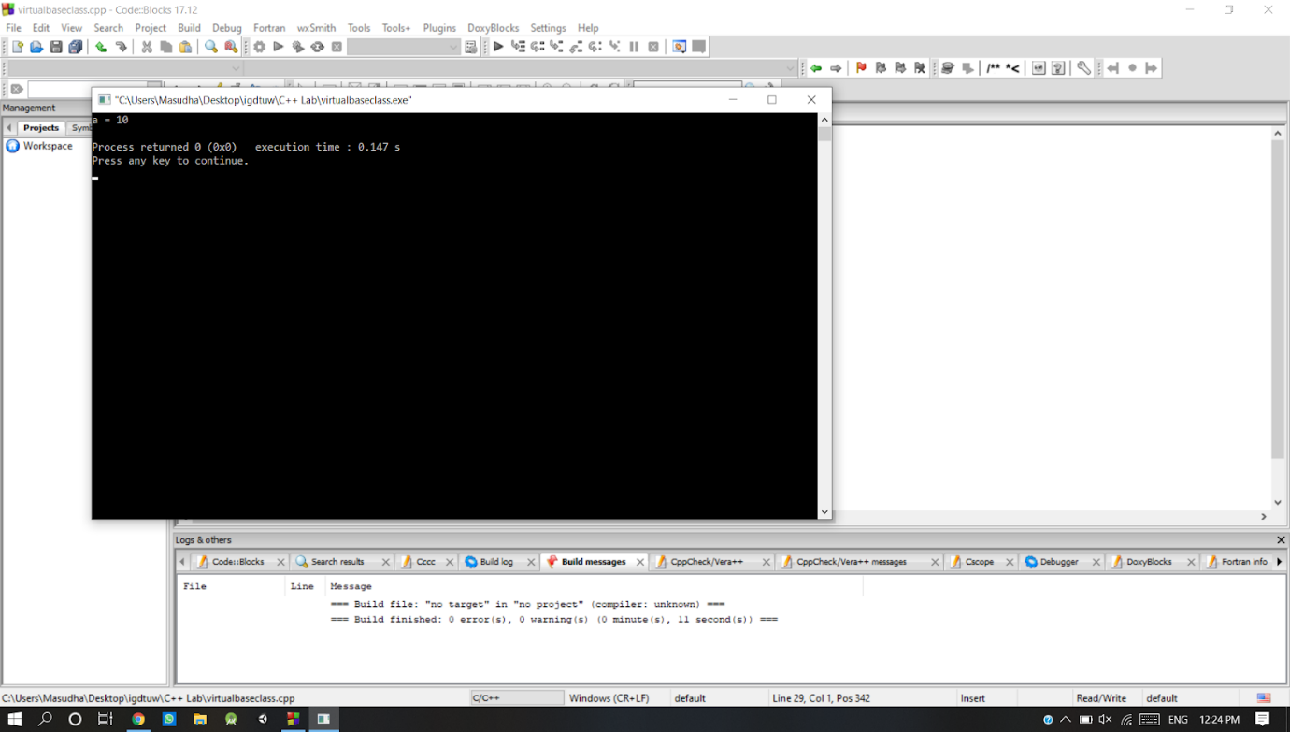

**Ques 22:** Write a C++ program that illustrates the use of pure virtual function. Create an abstract class *shape* which has *area()* and *perimeter()* as its member functions. These functions are overridden by inherited classes namely *rectangle, square, triangle* and *circle.*

**Solution 22:**

#include<iostream>

using namespace std;

#define PI 3.14

class shape

{

public:

virtual double area()=0;

double perimeter();

void setLength(double l){

length=l; //rectangle

}

void setBreadth(double b){

breadth=b; //height

}

void setHeight(double h){

height=h;

}

void setRadius(double r){

radius=r; //radius

}

void setSide(double s){

side=s;

}

protected:

double length; //rectangle

double breadth;//rectangle and triangle

double height; //triangle

double radius; //circle

double side; //square

double sideA; //triangle

double sideC; //triangle

};

class rectangle: public shape

{

public:

double area(){

return (length*breadth);

}

double perimeter(double l, double b){

return (2*(l+b));

}

};

class square: public shape

{

public:

double area(){

return(side*side);

}

double perimeter(double s){

return(4*s);

}

};

class circle: public shape

{

public:

    double area(){

         return (PI*radius*radius);

     }

     double perimeter(double r){

         return (2*PI*r);

    }

};

class triangle: public shape

{

public:

double area(){

return (0.5*height*breadth);

}

double perimeter(double a, double b, double c){

return (a+b+c);

}

};

int main(void)

{

rectangle rect;

square s;

circle c;

triangle t;

rect.setLength(5.57);

rect.setBreadth(4.67);

s.setSide(9.00);

c.setRadius(6.45);

t.setBreadth(5.56);

t.setHeight(8.9);

cout<<"************************************AREA AND PERIMETER*******************************"<<endl;

cout<<"Area of the rectangle is: "<<rect.area()<<" and perimeter is "<<rect.perimeter(5.57,4.67)<<endl;

cout<<"Area of the square is: "<<s.area()<<" and perimeter is "<<s.perimeter(9.00)<<endl;

cout<<"Area of the circle is: "<<c.area()<<" and perimeter is "<<c.perimeter(6.45)<<endl;

cout<<"Area of the triangle is: "<<t.area()<<" and perimeter is "<<t.perimeter(4.23,5.56,2.45)<<endl;

return 0;

}

**Output:**

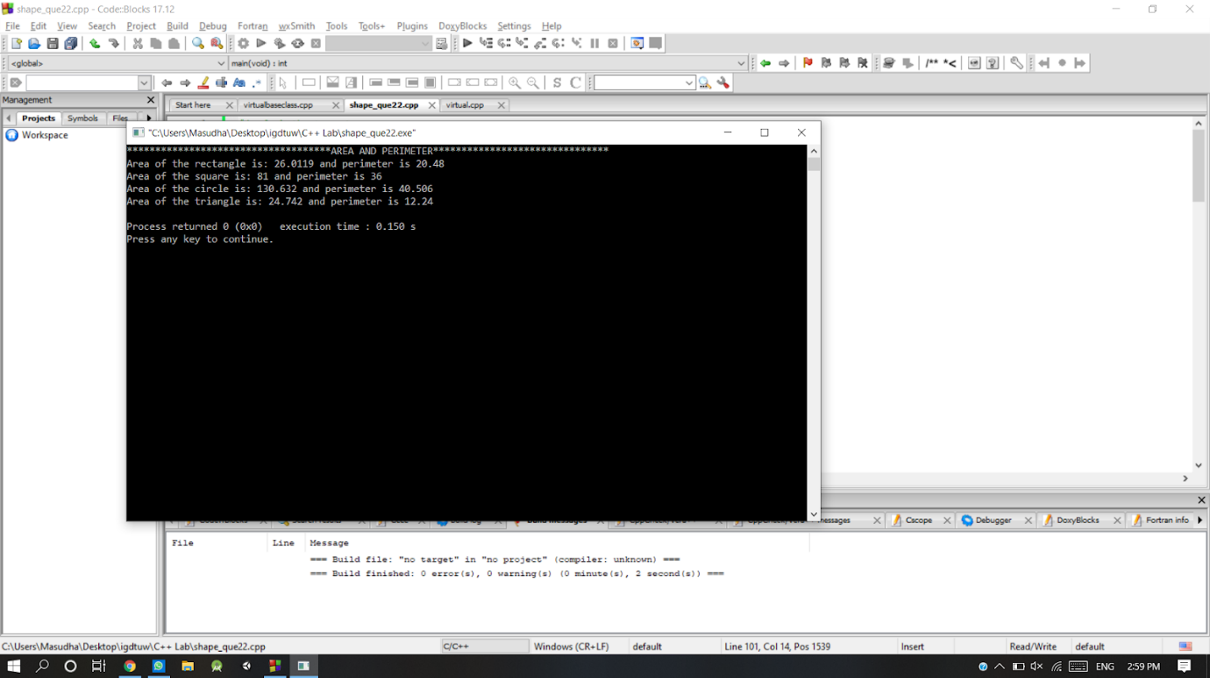

**Input/ Output**

**Ques 23:** Write a C++ program where a user reads the contents of a given text file and writes it to the standard output console

**Solution 23:**

#include<iostream>

#include<string.h>

#include<fstream>

#include<stdlib.h>

using namespace std;

int main()

{

ifstream ifile;

char s[100], fname[20];

cout<<"Enter file name to read and display its content (like file.txt) : ";

cin>>fname;

ifile.open(fname);

if(!ifile)

{

cout<<"Error in opening file..!!";

getch();

exit(0);

}

while(ifile.eof()==0)

{

         ifile>>s;

         cout<<s<<" ";

}

cout<<"\n";

ifile.close();

return 0;

}

**Output:**

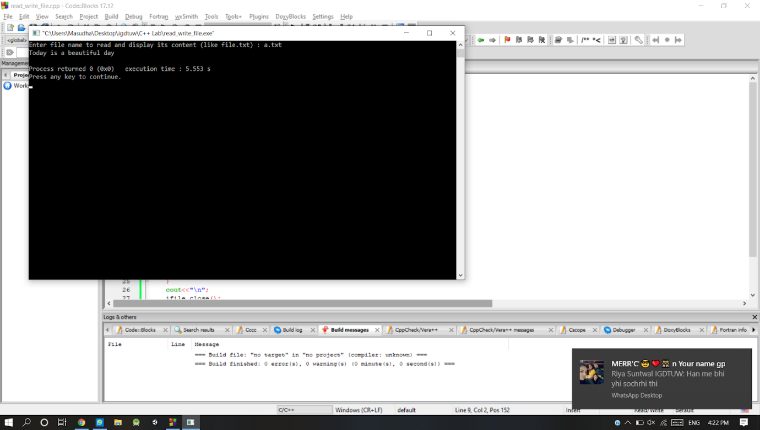

**Ques 24:** Copies the contents of a source file into the destination file

**Solution 24:**

#include <stdio.h>

#include <stdlib.h> // For exit()

int main()

{

FILE *fptr1, *fptr2;

char filename[100], c;

printf("Enter the filename to open for reading \n");

     scanf("%s", filename);

// Open one file for reading

fptr1 = fopen(filename, "r");

if (fptr1 == NULL){

         printf("Cannot open file %s \n", filename);

     exit(0);

}

printf("Enter the filename to open for writing \n");

     scanf("%s", filename);

// Open another file for writing

fptr2 = fopen(filename, "w");

if (fptr2 == NULL){

         printf("Cannot open file %s \n", filename);

     exit(0);

}

// Read contents from file

c = fgetc(fptr1);

while (c != EOF){

     fputc(c, fptr2);

     c = fgetc(fptr1);

}

     printf("\nContents copied to %s", filename);

fclose(fptr1);

fclose(fptr2);

return 0;

}

**Output:**

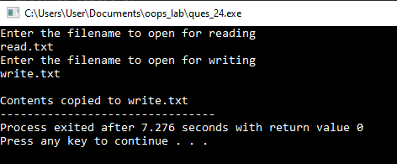

**Ques 25:** Write a C++ program for users to take the input from the standard console and write it to a text file.

**Solution 25:**

#include <iostream>

#include<fstream>

using namespace std;

int main(int argc, char** argv)

{

int n;

ofstream file;

file.open("command.txt");

if(!file){

cout<<"Error in creating file!!!"<<endl;

return 0;

}

for (int i = 0; i < argc; ++i){

file<< argv[i] << " ";

}

file.close();

return 0;

}

**Output:**



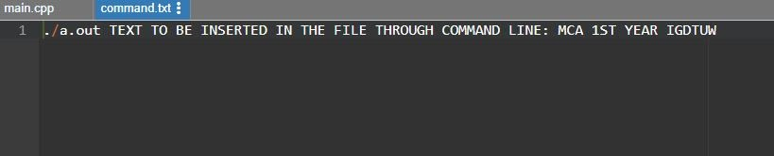

**Ques 26:** Write a program to check if a number entered by a user is even or not. If number is even then store in a file (even.txt) else store in a file (odd.txt)

**Solution 26:**

#include <iostream>

#include<fstream>

using namespace std;

int main()

{

int n;

ofstream file;

cout << "Enter an integer: ";

cin >> n;

if ( n % 2 == 0){

cout << n << " is even.";

file.open("even.txt",ios::out);

if(!file){

cout<<"Error in creating file!!!"<<endl;

return 0;

}

file<<n;

file.close();

}

else{

cout << n << " is odd.";

file.open("odd.txt",ios::out);

if(!file)

{

cout<<"Error in creating file!!!"<<endl;

return 0;

}

file<<n;

file.close();

}

return 0;

}

**Output:**





**Exception Handling**

**Ques 27:** Write a program to handle exceptions, different types of exceptions in C++

**Solution 27:**

#include <iostream>

using namespace std;

int main(){

int x = -1;

// Some code

cout << "Before try \n";

try {

cout << "Inside try \n";

if (x < 0){

throw x;

cout << "After throw (Never executed) \n";

}

}

catch (int x ) {

cout << "Exception Caught \n";

}

cout << "After catch (Will be executed) \n";

return 0;

}

**Output:**

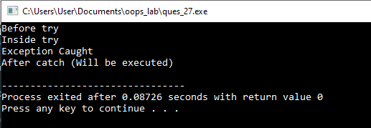

**Ques 28:** Division by zero is an exception. Write a C++ program to detect such an exception and *handle it by displaying an appropriate message and exit from the program.*

**Solution 28:**

#include <iostream>

using namespace std;

/*Because we are raising an exception of type const char*,

so while catching this exception,

we have to use const char* in catch block.

If we compile and run above code,

this would produce the following result */

double division(int a, int b) {

    if( b == 0 ) {

   throw "Division by zero condition!";

    }

    return (a/b);

}

int main () {

int x = 50;

int y = 0;

double z = 0;

try {

z = division(x, y);

cout << z << endl;

}

catch (const char* msg) {

cerr << msg << endl;

}

return 0;

}

**Output:**

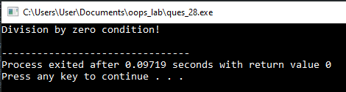

**Ques 29:** Write a C++ program to illustrate the concept of re-throwing an exception.

**Solution 29:**

#include <iostream>

using namespace std;

void MyHandler(){

try{

throw "hello";

}

catch (const char*){

cout <<"Caught exception inside MyHandler\n";

throw; //rethrow char* out of function

}

}

int main(){

cout<<"Main start";

   try {

    MyHandler();

    }

    catch (const char*){

   cout <<"Caught exception inside Main\n";

   }

    cout <<"Main end";

    return 0;

}

**Output:**

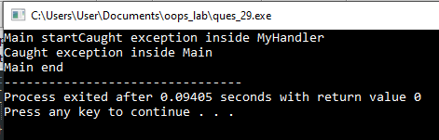

**Ques 30:** Write a program to handle an exception thrown by new.

**Solution 30:**

#include <iostream>     // std::cout

#include <new>          // std::nothrow

int main () {

std::cout << "Attempting to allocate 1 MiB... ";

char* p = new (std::nothrow) char [1048576];

if (!p) {             // null pointers are implicitly converted to false

std::cout << "Failed!\n";

}

else {

std::cout << "Succeeded!\n";

delete[] p;

}

return 0;

}

**Output:**

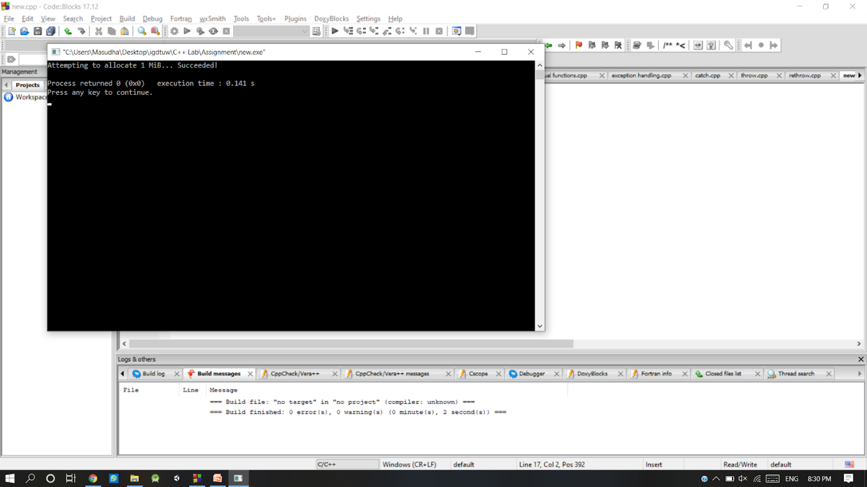

**Namespace**

**Ques 31:WAP to illustrate the use of functions defined within a user defined namespace.**

**Solution 31:**

// Using namespaces, we can create two variables or member functions having the same name.

#include<iostream>

using namespace std;

namespace first{

            int value(){

return 5;

            }

}

namespace second{

            const double x=100;

            double value(){

return 2*x;

            }

}

int main(){

cout<<first::value()<<"\n";

cout<<second::value()<<"\n";

cout<<second::x<<"\n";

return 0;

}

**Output:**

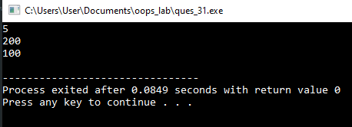

**Ques 32: WAP to create within user defined namespace and create the objects of class using scope resolution and using directive.**

**Solution 32:**

#include<iostream>

using namespace std;

namespace first{

int i;

}

namespace second{

int i;

}

int main(){

first::i=1;   //scope resolution

second::i=2;

using first::i; //using directive

cout<<i;

return 0;

}

**Output:**

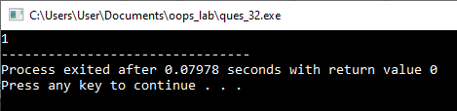

**Ques 33: Write a Program to show the concept of nested namespace.**

**Solution 33:**

#include <iostream>

using namespace std;

int x = 20;

namespace outer {

   int x = 10;

namespace inner {

int z = x; // this x refers to outer::x

}

}

int main()

{

std::cout<<outer::inner::z; //prints 10

return 0;

}

**Output:**

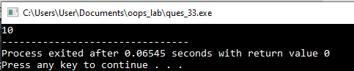

**Template**

**Ques 34:** Write a C++ program that represents a collection of elements of pre-defined using template class. The template class should provide the following features:

1. adding a new element
2. deleting an existing element
3. displaying the collection of elements

**Solution 34:**

**Ques 35:** Write a C++ program to illustrate the concept of template function by writing template function which performs the following tasks:

1. addition of two given type
2. subtraction of one type with another type

**Solution 35:**